* Collection of Book which contains information such as book title, author, publication, edition, year of publication, ISBN_no and type of book.

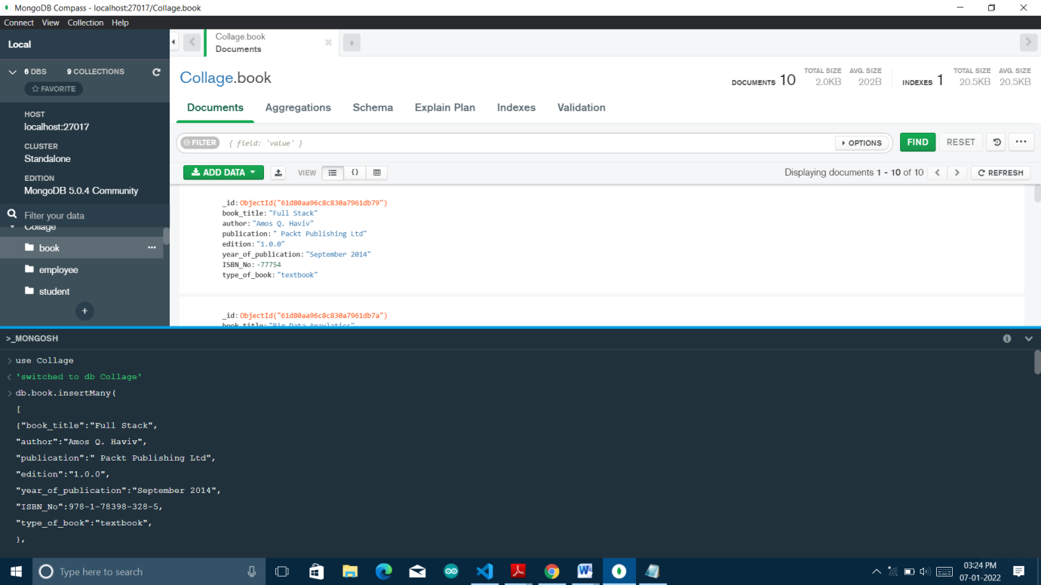

* Retrieve the book which contain the title as java :

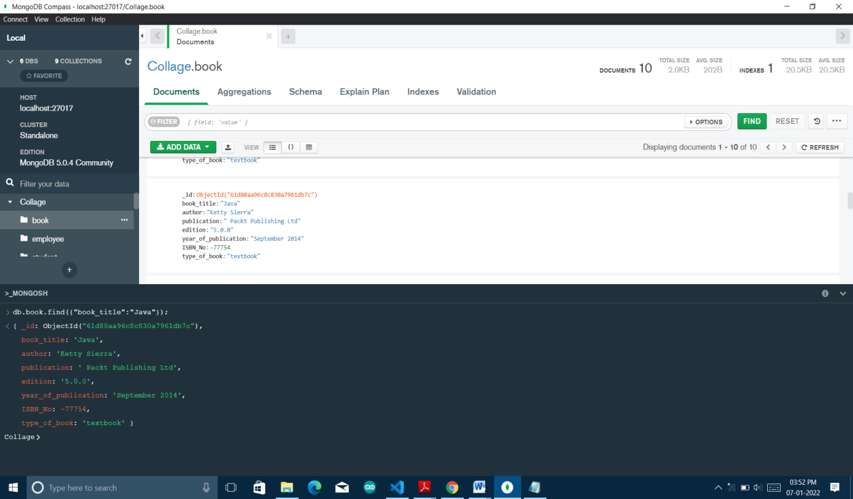

* Retrieve the book which contain the title as java and year of publication > 2010

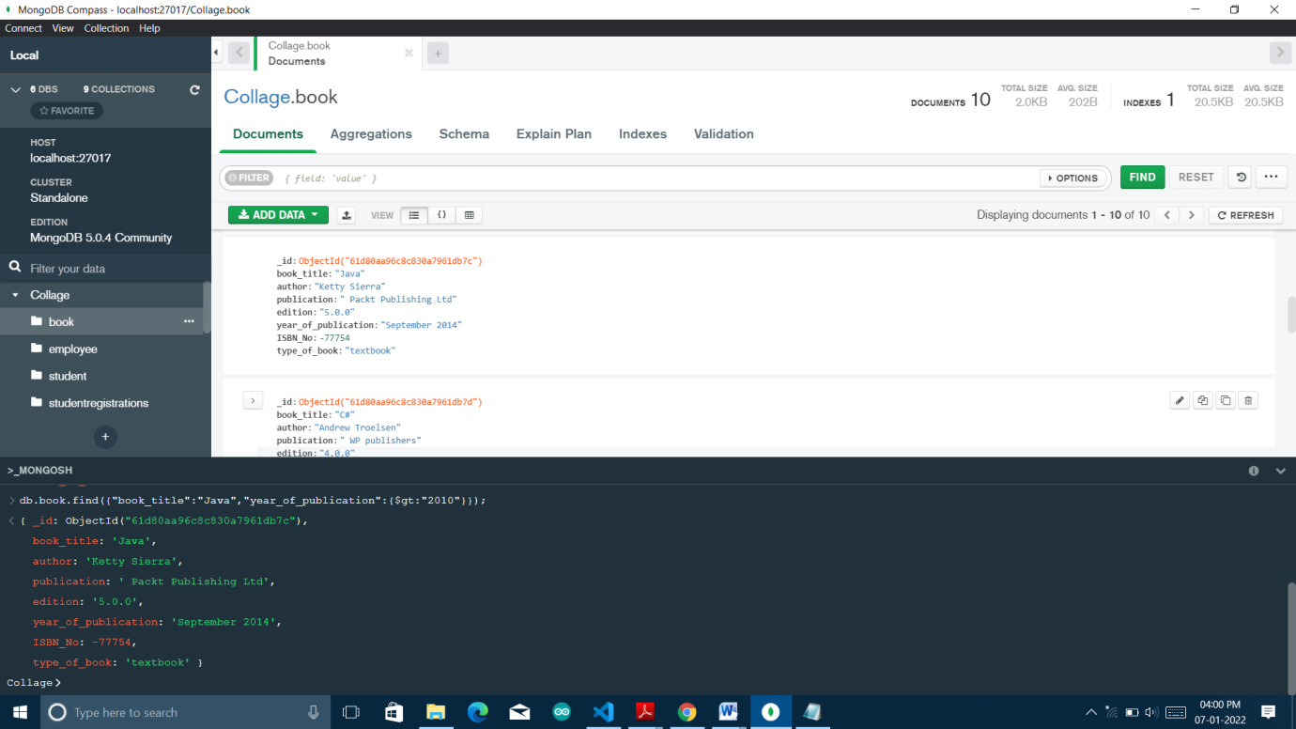

* Retrieve the name of author who has published more than 2 books :

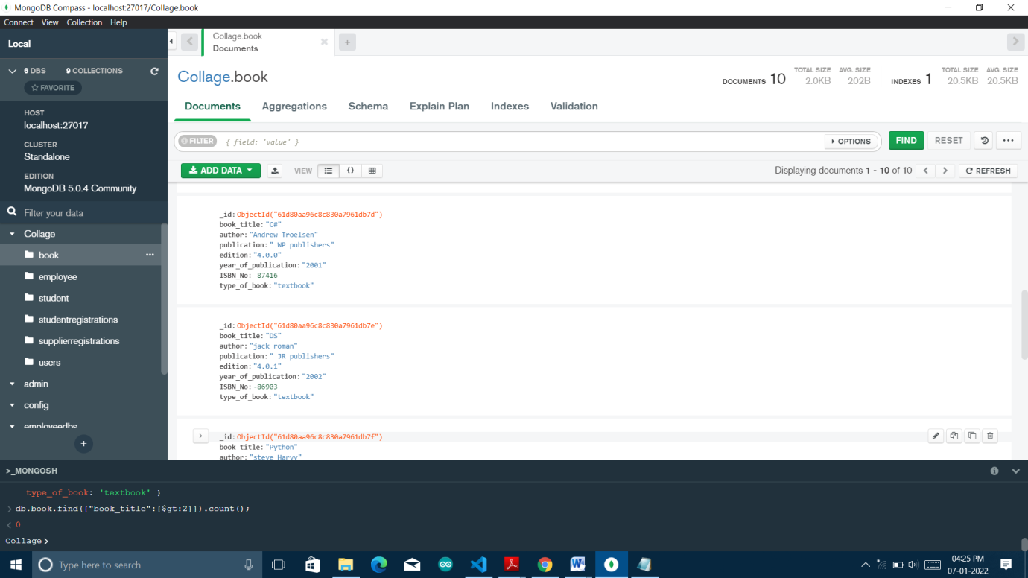

* Retrieve the book whose edition is between 3 to 4 :

